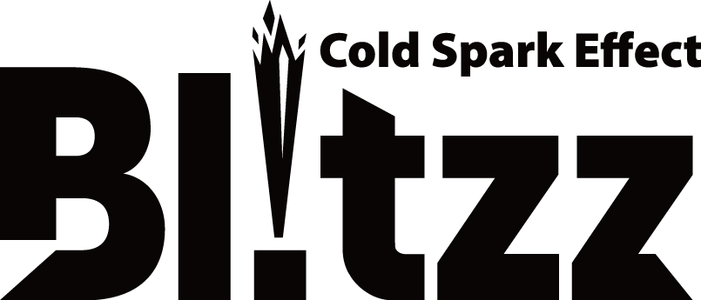



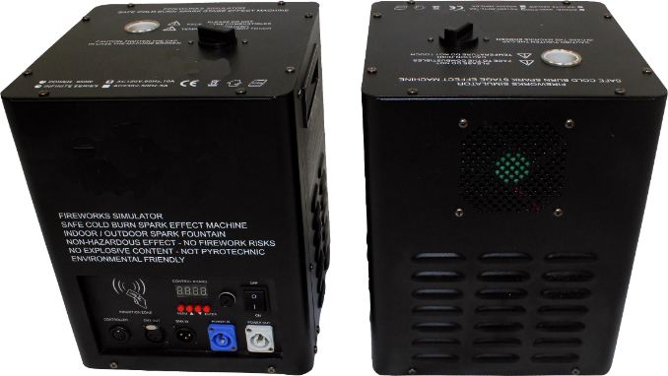X-BLITZZX2

FIREWORKS SIMULATOR

SAFE COLD SPARK EFFECT MACHINE

INDOOR / OUTDOOR SPARK FOUNTAIN

NON-HAZARDOUS EFFECT - NO FIREWORK RISKS

NO EXPLOSIVE CONTENT - NOT PYROTECHNIC

NO GUNPOWDER – NO IRRITANT

ENVIRONMENTALLY FRIENDLY

**Xstatic Pro, Inc.**

**901 Essex Street**

**Brooklyn, NY 11208 USA**

Office. 718-237-2299

Fax 718-237-2318

www.ProXDirect.com

**Read & follow the entire manual before using this Machine!**

Reserved: This space intentionally left blank.

***Note:*** *Each pair of machines will be shipped with a bag of spark powder for testing. Each machine has 1200 seconds of use without a scan card for testing purposes. The remaining time will be displayed on the LCD display after the words PROX BLITZZ. Thereafter a safety card must be scanned!*

**IMPORTANT SAFETY CONSIDERATIONS:**

1. With the power disconnected, place the UNIT horizontally, and inspect it for damage on all sides before each use. If damaged, do not operate and contact ProX for service.
2. Unscrew the lid of the powder tank to pour in the ProX powder, and then lightly tighten the lid. (Use ONLY ProX branded powder)
3. Before power on, please verify that the supply voltage is in conformity with the rated voltage of the machine. At power on, the indicator light will turn on, and the machine will begin to heat for use. Connect the machine to your preferred controller. Once heated for use, it will remain ready as long as power is connected.
4. The machine must be used only in a well-ventilated place. Although this is a COLD effect, it may create a very small amount of smoke/haze during operation.
   1. Do not allow machine to run out of powder. If the machine is allowed to run empty, it may cause the mechanical system to be damaged.
   2. **IMPORTANT: Turn off the power before adding effect powder.**
5. **Outdoor powder** *CANNOT* be used indoors! When using outdoor powder there should be no flammable materials in a 10 ft. radius around and under the Blitzz machine.
6. Spark powder should not be exposed to the air. Once a bag of powder is opened it should be used up or placed in an airtight sealed container. Never expose spark powder to open flames. Do not discard in fire.
7. Do not touch the device during operation as the housing will be hot to touch. Provide a minimum of a 3-foot safe zone with nothing but the power and signal cables for the Blitzz units in that area. Provide a 16-foot separation between the machines and the audience and any other obstruction!
8. Keep this device in a dry area at all times. Do not allow water to enter the unit at any time.
9. **NOTE**: The Blitzz machines **MUST** be in the vertical position at all times when there is powder in the tank. Remove all powder prior to transport or risk creating a blockage in the mechanical system.
10. Disconnect all power servicing the unit. No operator serviceable parts inside. Return to ProX for repairs or refurbishing.
11. Damage caused from not following the guidelines in this manual are not covered by the warranty and ProX will not accept responsibility for any resulting defects or problems.
12. A qualified technician should install and service this device.
13. Do not switch the device on immediately after it has been exposed to extreme changes in temperature especially very cold conditions. Protect the device against damage by leaving it switched off until it has reached room temperature.
14. This device falls under NEC Class 1. It is essential that the device be earth grounded. Do not remove or isolate the grounding pin.
15. Make sure that the available voltage does not exceed the voltage stated in the specification section of this manual.
16. Do not crimp the power cord. Protect it against damage. Have an authorized service center replace it if necessary.
17. Disconnect the device from all power to clean it or when it is not in use. Handle the power cord by the plug ends only.
18. Note that ANY modification to the device is not covered by the product warranty and will VOID the warranty.
19. Keep the device away from children and untrained/unauthorized users.

**IMPORTANT NOTICE: NEVER POUR SPARK POWDER INTO THE SPARK DISCHARGE OPENING! THIS CAN BE DANGEROUS! SPARK POWDER MUST ONLY BE ADDED TO THE STORAGE TANK THAT REQUIRES THE REMOVAL OF THE PROTECTIVE CAP. DO NOT OVERFILL! AFTER FILLING REPLACE CAP AND TIGHTEN.**

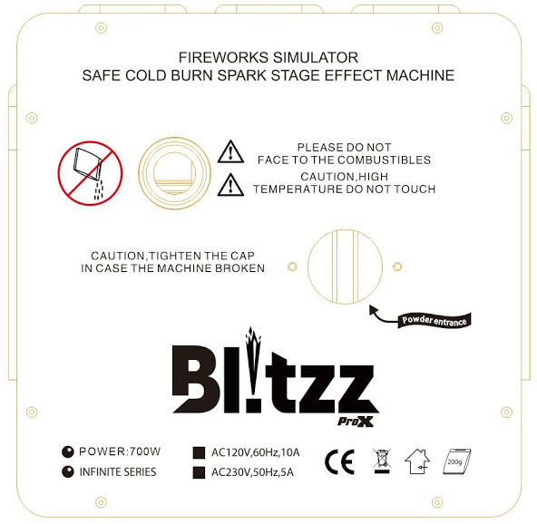 **USE PROX BRANDED SPARK POWDER ONLY!**

* CERTIFIED ADULT OPERATOR USE ONLY
* DO NOT OPERATE WITHOUT SPARK POWDER.

**POWDER**

**NO!**

* DO NOT SHOOT TOWARD PEOPLE OR COMBUSTABLES.
* ALLOW MINIMUM 16FT BETWEEN SPARK PORT

AND SPECTATORS/GUESTS/DECORATIONS.

* KEEP DRY - IP20 – STORE IN A SECURED DRY AREA

**POWDER**

**YES!**

* DISCONNECT POWER BEFORE CHANGING FUSE.
* DO NOT OPEN THE CASE, RISK OF ELECTRIC SHOCK!
* NO USER SERVICEABLE PARTS INSIDE.

**Details:**

1. 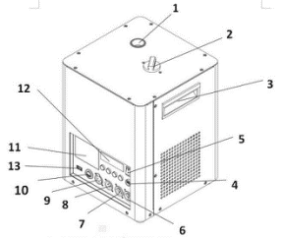Spark Output ***(DO NOT ADD POWDER HERE!)***
2. Cap for Powder Loading
3. Lifting Handle
4. Fuse 10 Amp.
5. On/Off Switch
6. 115V AC Power Out
7. 115V AC Power In
8. DMX-512 Connector In
9. DMX 512 Connector Out
10. Wired Controller Connector
11. Safety Card Scan Area
12. LCD Digital Display
13. USB Connector (for future firmware updating)

**Operation**

* Have the device operated by a qualified person, respecting IEC 60598-2-17 and all other applicable codes
* Never stand directly below the device when it is being mounted, removed or serviced. Have a qualified technician check the device annually and additionally before placing into service if stored for an extended period of time.
* Install the device in a secure location that is inaccessible to unauthorized persons.
* Make sure there is no flammable material within a 16ft radius of the device.
* Use a clean and dry rag to remove dust. Metal parts can be cleaned with a damp cleaning rag.

1. Open the transport case and carefully remove each unit.
2. Set the Blitzz vertical on a firm flat dry surface. Do not invert or lay ln side!
3. Fill the powder reservoir with our ProX powder only then tighten the cap. *Safety card is in powder bag.*
4. Scan the safety card AFTER loading powder. Card is SINGLE use!
5. Press MENU button to check remaining time after each use if desired. Remaining time shown as seconds.
6. Firmly attach the remote-control unit to the rear remote-control socket on the unit.
7. Plug the unit in to a proper power source. Wait several minutes for the device to reach normal operating temperature. When it has reached the operating temperature, and is ready to operate with sparks, the digital display board at rear will show “READ” and the ready LED on the remote will glow also.
8. You can press wired controller or wireless controller or DMX to emit output.

**Daisy chain the machines:**

You may connect the machines with IN/OUT Series connectors up to 3 machines on a single 15A 115VAC power outlet. An unlimited number of machines may be daisy chained by DMX cables, but only 3 on each power outlet.

**Menu：**



Menu：Press ENTER

1. Address DMX512： 1-512

2. Volume Out: Minimum: 1%, Maximum: 100%

3. Tip Over: On/Off Dumping alarm ON or OFF when machine tilt is less than 45deg.

4: Manual Test: Start the machine for manual testing use only

**TIP OVER:** Set to ON or OFF If ON & the machine is tilted more than 45 degrees the machine will stop working and the LCD with flash as a warning. If set to OFF there is NO PROTECTION!

**DMX SETTINGS:**

Channel Settings

|  |  |
| --- | --- |
| ***Channel 1*** | ***Function*** |
| 0 | Spark effect **OFF** |
| 1-255 | Spark effect **ON** |
| ***Channel 2*** | ***Function*** |
| 0-20 | Preheating function OFF, and the channel 1 is blocked |
| 50-100 | Preheating function ON. and the channel 1 is operational |
| 150-200 | Clean up the consumables（maximum 15 seconds run time AND channel 1 is blocked |

**Specifications:**

Rated Voltage: AC120V/60Hz

Rated Current: 5.8 Amp.

Rated Power: 700W

Fuse: 10 Amp.

Preheating: Typically, less than 8 minutes

***Recommended*** Fountain Height: Indoor 0 – 4 feet Outdoor 0 – 16 feet

Fountain Height Select: Controlled VIA Wireless Remote or DMX programming

Panel Display: LCD Digital Display

Product Net Weight: 22 lbs.

Product Size: 9 3/4” x 9 5/8” x 12 5/8”

**W-3 Wireless Controller *Wireless RF Controllers:***

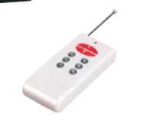 **W-3 Controller Usage Instructions：**

#1 - **START** (Push to **Start**, Push #2 to **Stop**)

#2 - **STOP** (Manual Shut Down) - ***Power Clean* AFTER WARMUP! *(Push and hold #2 for more than 10 seconds to start clean cycle, it will run 15 seconds or Press #2 again to stop***. **This ONLY removes granules in the spark tube, not storage tank!**

#3 - Duration time 10s (the machine will run continuously 10 seconds)

#4 - Open group-1（wireless ADDR=1） (press down the button— turns on #2 to stop)

#5 - Duration time 20s (the machine will run continuously 20 seconds)

#6 - Open group-2（wireless ADDR=2） (press down the button—turns on #2 to stop)

#7 - Duration time 30s (the machine will run continuously 30 seconds)

#8 - Open group-3（wireless ADDR=3 (press down the button— turns on #2 to stop

**W-3 Wireless Receiver**

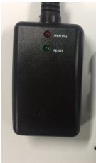

**To clear granules from storage tank, allow machine to cool, then remove tank cap**

**and invert machine to shake granules out of tank. Store or dispose of properly!**

***W-3 Receiver /Dip Switch Usage Instructions：***

***When the machine is ready to spark, the ready LED will glow.***

***There are 3 Channels (Dip 1-3) CAN SELECT for group-1, group-2, group-3***

**Instructions are printed on the back of the wireless controllers!**

**Wired Remote:**  **After pre-heating green light will turn on, Press the button once to start effects:**

1. Ensure that the power outlet matches that of the required voltage for your machine.

Do not EVER remove or lift the grounding of the unit.

1. The unit should be used in a well-ventilated area. NEVER COVER THE FOUNTAIN PORT WITH ANYTHING WHEN IN USE.
   1. Before filling powder, you should turn off the power. If any consumables fall into the interior of the unit, immediately disconnect the power cord.
   2. The unit is not waterproof in any manner. If moisture or liquid enters the machine, unplug the power cord and allow to dry.
   3. Under no circumstances should you try to operate the Blitzz machines if you do not have the appropriate qualifications and certification! It may result in personal injury or damage the unit.
   4. Only for professional adult use, keep safe distance from spectators and/or guests
   5. Keep away from flammable and explosive goods.
   6. Maintain a clear, exclusionary, 3-foot radius around the machine when in use and a 16-foot radius safety area. The fountain nozzle area temperature can become quite hot during operation, do not touch this area during use or immediately following usage.
   7. Allow time for cooling between bursts and after operation is complete.
   8. If you experience excessive haze output, little spark, pump noise or no spark output at all, Disconnect and discontinue use immediately. Check fluid level, powder, the external fuse, remote connection and be sure the wall outlet is providing proper power. Only use our powder and the machine can produce a perfect effect.

**Warranty Instructions**

1. Warranty period：**One** **Year** *(the date and proof of purchase MUST be registered)*
2. Register Here: <https://www.proxdirect.com/support/warranty>
3. IF the buyers do not use ProX spark powder, the machine warranty will be voided. The buyer will pay for the expenses if there are any components damaged due to misuse or use of improper supplies.
4. In the following cases, the product will not be warranted:
5. The product has been incorrectly operated and used inadvertently, for example, over load, over pressure, and firing too long;
6. The product was broken because of careless handling;
7. Damage due to poor protection from environmental factors and quality problems, such as: humidity, voltage instability, etc.;
8. Products have been modified by non-factory authorized personnel.
9. Usage of any spark granules/powder not manufactured by ProX
10. Items not covered by the warranty include: packaging, product shell and hanger, remote control transmitter batteries.
11. Products that are used in compliance with the warranty provisions, ProX will not charge labor or parts cost. Product must be returned to ProX for servicing. Return for service must be pre-authorized and shipments not authorized will be refused. After warranty expires, standard repair costs will apply.
12. The owner’s compliance with the warranty will be *solely* interpreted by ProX.

*Traditional pyrotechnic effects burn at 1200 degrees Fahrenheit, and cannot be stopped once they have been started. This can lead to all kinds of hazards and problems.*  ***Not with the Blitzz however!***

Safety is always the number one concern when dealing with these types of effects.

The PROX BLITZZ operates at very cool temperatures (60°F to 70°F; the sparks themselves are not flammable. The machines are designed to be very smart and have multiple built-in safety protocols. You can control the start and stop of the effect at any time. You now can control the time, height, volume this has never been achieved from conventional pyrotechnics ever. This is beginning of a new technology to the world of stage of effects

**Cold Spark Machine**

Are you looking forward to experiencing a breath-taking indoor fireworks display? If yes, you need special effects spark machines to achieve your desired stunning displays. The Cold Spark Blitzz Machine, also known as a cold spark effect, is a safe to use, spark machine as it emits cold sparks which are not subject to catching fire. This device is not pyrotechnics but a simulated pyrotechnic experience.

**The Cold Spark Machine Special Effects**

The Cold Spark Machine allows its user to customize how the sparks should appear. The users have the luxury of controlling the sparks’ timing, volume as well as how high they rise for whatever production. You will simply be in control all through.

**Blitzz Spark Machine Cost**

These special effects spark machine’s cost of operation is very favorable despite its stunning abilities. The ProX Blitzz package boasts of the best price tags in the market/ industry. By choosing the ProX Blitzz you are guaranteed of high technology & safety as well as value for your money. The material used for the special sparks effects is durable since it has a long shelf life. It is therefore advisable for bulk stocking to achieve reduction of expenses.

**Cold Spark Effect**

The safe and convenient special effects spark machine. Safety should be your number one priority. The Cold Spark Machine as mentioned earlier does not catch fire. The Cold Spark Machine fountain system allows for safe creation of the stunning desired sparks effects. This machine is fully programmable and easy to set up. The users of the ProX Blitzz Cold Spark Effect Machine, with a standard DMX controller, are able to simultaneously control multiple units and up to 3 units from a single 15A standard power supply circuit.

The ProX Cold Spark Machine can be used in any environment setting since its sparks are not flammable and with an almost zero possibility of abuse or misuse. Its units are high tech and consist of built in safety protocols hence their operations can be kept under maximum control.

# Blitz Cold Spark Safety Requirements

 WARNING: A WARNING ALERTS YOU TO HARMFUL OR POTENTIALLY DANGEROUS ACTIVITIES. A DESCRIPTION OF THE HAZARD IS GIVEN AND THE CONSEQUENCES OF IGNORING THEM.

***Please note that the ProX Blitz units are not meant to be a continuous duration effect. The maximum running time is 60-90 seconds and can be repeated but should not be done too RAPIDLY to NOT allow cooling TIME BETWEEN bursts!***

# **Eye Protection**

THE EYE PROTECTION WARNING ICON IS SHOWN TO INDICATE THAT YOU MUST BE PROTECT YOUR EYES WHEN CLOSE TO THE MACHINE DURING MACHINE OPERATION.

# **Injury Voltages**

WARNING: DANGEROUS VOLTAGES ARE PRESENT IN THIS MACHINE AND CONTROLLER WHEN ELECTRICAL POWER IS APPLIED. THERE IS A DANGER OF INJURY FROM ELECTRIC SHOCK.

UNDER NO CIRCUMSTANCES ARE YOU TO ATTEMPT TO OPEN THE MACHINE AND CONTROLLER OR ATTMPT TO REMOVE OR ADJUST ANY COMPONENTS FITTED WITHIN THE MACHINE AND CONTROLLER. ONLY FULLY TRAINED PROX SERVICE ENGINEERS ARE QUALIFIED TO OPEN THE MACHINE AND CONTROLLER.

# **Liquid Cautions**

WARNING: USE CAUTION SO THAT ANY LIQUIDS DO NOT WET THE MACHINE. KEEP THE MACHINE AND CONTROLLERS DRY AND DO NOT USE ON RAINY OR SNOWY DAYS UNLESS COVERED. DO NOT COVER FOUNTAIN PORT DURING OPERATION!

### **Warning**

PLEASE PREVENT ANYTHING FROM ENTERING THE FOUNTAIN DISCHARGE PORT. IF THIS HAPPENS PLEASE CLEAR OBSTRUCTIONS BEFORE CONTINUING OPERATION. DO NOT DROP THE MACHINES, SERIOUS DAMAGE CAN OCCUR.

# **Granules**

IF THE BAGGED GRANULES ARE INVOLVED IN A FIRE THE SUGGESTED METHOD OF EXTINGUISHING IS BY SAND OR DRY CHEMICAL EXTINGUISHER. DO NOT TRY TO EMPTY THE MACHINE AS THIS WILL RESULT IN EXPOSING THE GRANULES. USE ONLY THE GRANULES FROM PROX DESIGNED FOR THE BLITZ MACHINES. USE OF OTHER SIMILAR GRANULES WILL VOID THE WARRANTY.

## **Safe Distance**

****KEEP AUDIENCE AND FLAMMABLE MATERIALS AT A MINIMUM SAFETY DISTANCE OF 10 FEET. KEEP OUT OF REACH OF THE PUBLIC! MAINTAIN A 3 FOOT EXCLUSION ZONE AROUND EACH MACHINE WITH NOTHING BUT THE POWER AND CONTROL CABLES IN THIS AREA!

# **In Case of Emergency**

IF THE MACHINE NEEDS TO BE STOPPED QUICKLY DUE TO AN EMERGENCY, PRESS THE “PAUSE” / “STOP” KEY ON THE CONTROLLER TO STOP THE MACHINE AND TURN THE POWER SWITCH ON THE PANEL OF THE MACHINE TO THE “OFF” POSITION.

**CALL FOR MEDICAL ASSISTANCE AS REQUIRED.**

# **Noise Emissions**

THE NOISE EMISSION LEVEL FROM THIS MACHINE DOES NOT EXCEED 80 DB. THERE IS NO HAZARD TO HEARING AND, THEREFORE, NO LEGAL REQUIREMENT FOR EAR PROTECTION TO BE WORN WHEN WORKING IN THE VICINITY OF THIS MACHINE.

# **Cleaning**

PLEASE INSPECT FOUNTAIN NOZZLE OF THE BLITZ MACHINE BEFORE USE AND CONFIRM THERE ARE NO ACCUMULATED GRANULES. PLEASE CLEAN OUT ANY EXCESS BY INVERTING THE UNIT TO CLEAN OUT PORT. THIS SHOULD BE DONE EACH TIME BEFORE THE MACHINE IS SETUP AND BE PERFORMED BEFORE RETURING THE UNITS TO THEIR ROAD CASE. THIS WILL HELP TO PROLONG THE LIFE OF THE BLITZ MACHINE. THE FOUNTAIN PORT CAN BE CLEANED WITH A BOTTLE BRUSH AS NECESSARY. AN AUTOMATED QUICK CLEAN CAN BE PERFORMED BY PRESSING THE #2 BUTTON ON THE WIRELESS REMOTE AND HOLDING FOR 10 to 15 SECONDS TO START CLEAN CYCLE, PRESS #2 AGAIN TO STOP.

## **Power Supply Requirement**

POWER REQUIREDMENTS ARE 115VAC 6 AMPS EACH. ***PLEASE NOTE:*** ONE STANDARD 15 AMP CIRCUIT SHOULD SUPPORT A MAXIMUM OF 3 PROX BLITZ MACHINES IN NORMAL OPERATIONS. EACH MACHINE CAN BE CONNECTED INDIVIDUALLY OR DAISY CHAINED WITH POWER-CON SERIES CABLES FOR UP TO 3 MACHINES MAXIMUM ON ONE CIRCUIT.



**Xstatic Pro, Inc. - ProX**

901 Essex Street, Brooklyn, NY 11298

Voice 718.237.2299 – Fax: 718.237.2318

Email: info@proxdirect.com

**(NO DIRECT SALES, DEALERS AND DISTRIBUTORS ONLY)**

Register your products on ProXDirect.com