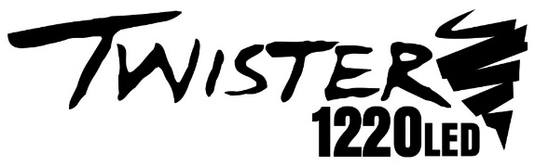
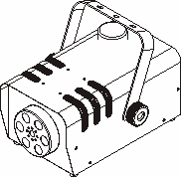

X –T1220 LED FOG MACHINE
USER MANUAL

Product Description:
X-T1220 LED Fog Machine:
Its compact body, stable and practical performance, fog with dazzling RGBA LED lights.

Features:
1: Practical, compact & good value
2: Both wired and wireless controllers makes unit easy to operate.
- LED lights enhance the color of the fog.
NOTES:
▶The unit should be cleaned every 30 to 60 days depending on usage.
Cleaning Method: Remove all fluid from the unit, then Mix 20% white vinegar plus 80% distilled water and add this mix to unit. (You can also purchase ProX Fog Juice Cleaner.) Then cycle 3-5 times after heating the cleaning solution!
▶The machine should use ProX Fog Juice, which with distilled water formula, to prolong the life of machine.
▶Please keep your controllers protected. Lost controllers are not provided under the product warranty.
▶Use only authorized ProX replacement parts to maintain warranty.

NOTES BEFORE USE:
1. Place the fog machine horizontally, and inspect for damage at each use. If damaged, please contact ProX for service. Unscrew the lid of the fluid tank to pour in the ProX Fog Juice, and then lightly tighten the lid.
2. Before power on, please verify that the supply voltage is in conformity with the rated voltage of the smoke machine. At power on, the indicator light will turn on, and the fog machine will begin to heat for use. Connect the machine to your selected controller.
3. At initial use the machine may produce a limited amount of fog, wait for it to fully heat and be ready for service.
4. The machine must be used only in a well ventilated place but not where is air flow if limited or the machine's thermal protection system may cause a shutdown.
5. The fog machine can be used on the ground horizontally or installed level on a truss or support. The machine should have 12 inches clearance all around. Keep away from children, flames, flammable and explosive materials. Keep a minimum of 16 inches away from the output nozzle to prevent scalding.
6. Do not allow machine to run out of fluid. If the machine is allowed to run empty, it may cause the pump and/or heater to be damaged. Turn off the power before adding fog fluid and do not allow fluid to enter the inside of the housing, as internal electrical damage may result.
7. If fog output is low, or there is noise from pump, or the machine stops creating fog altogether, disconnect the power at once, and check the fluid level, fuse, cable and power plug. If you are unable to restore operation, contact ProX for service.
8. Do not allow the machine to operate without an attendant present. Do not add flammable liquids such as oils or any fragrance additives.
9. Due to condensation, vapor or moisture might gather around the nozzle of machine, this is normal depending on the temperature and humidity of the room. There might be some excess fog ejected from the machine during operation or after shutdown until the unit cools completely.
10. Please make sure there is no liquid or foreign matter inside the machine housing before powering the unit at each use. Do not modify or repair the machine by yourself. If there is any problem, please contact ProX or authorized service center.

1. Introduction
Important environmental information about this product.
This symbol on the device or the package indicates that disposal of the device after its life cycle could harm the environment.
Do not dispose of the unit (or components) as unsorted municipal waste; it should be taken to a specialized company for recycling.
- This device can be returned to your distributor or to a local recycling center.
- Respect local environmental rules and the environment.
- If in doubt, contact your local waste disposal authorities.
- Thank you for choosing ProX products. If the device was damaged in transit, do not operate or install the unit and contact your dealer.

2. Safety Instruction
- Be very careful during installation: touching live wires can cause life-threatening electrical shock.
- Do not touch the device during operation as the housing gets hot.
- Keep this device in a dry area at all times.
- Disconnect all power before opening the housing for any reason.
- Damage caused from not following the guidelines in this manual are not covered by the warranty and ProX will not accept responsibility for any resulting defects or problems.
- A qualified technician should install and service this device.
- Do not switch the device on immediately after it has been exposed to extreme changes in temperature. Protect the device against damage by leaving it switched off until it has reached room temperature.
- This device falls under NEC Class 1. It is essential that the device be earth grounded. Do not remove or isolate the grounding pin.
- Make sure that the available voltage does not exceed the voltage stated in the specification section of this manual.
- Do not crimp the power cord. Protect it against damage. Have an authorized service center replace it if necessary.
- Disconnect the device from all power to clean it or when it is not in use. Handle the power cord by the plug only.
- Note that damage caused by user modification to the device is not covered by the product warranty.
- Keep the device away from children and unauthorized users.
3. General Guidelines
- This device is designed for professional use on stages, clubs, theaters, etc. The device should only be used indoors with a 120 Volt 60 Cycle power supply.
- Do not shake the device. Use care when installing or operating the device.
- Select a service location where the device is protected against extreme heat, dust and moisture.
- Familiarize yourself with the functions of the device before actually using it. Do not allow operation by unqualified people. Any damage to the unit would likely be due to unprofessional use of the device.
- Use the original packaging or an appropriate case if the device is to be transported.
- All modifications of the device are prohibited for safety reasons and will void the warranty.
- Only use the device for its intended purpose. All other use may lead to short circuits, burns, electrical shocks, etc. Using the device in an unapproved manner will void the warranty.
- This device is not designed for permanent operation. Excessive usage may reduce the life span of your fog machine.
4. Operation
Have the device operated by a qualified person, respecting IEC 60598-2-17 and all other applicable codes
Any mounting structure must be able to support 10 times the weight of the device for 1 hour without deforming.
Never stand directly below the device when it is being mounted, removed or serviced. Have a qualified technician check the device annually and additionally before placing into service if stored for an extended period of time.
Install the device in a secure location that is inaccessible to unauthorized persons.
Adjust the desired inclination angle via the mounting bracket and tighten the bracket screws.
Make sure there is no flammable material with a 12 inch radius of the device.
- Technical Specifications
Voltage: AC 120V 60Hz
Power: 1200w / 120v
Current-Limited Safety Device: 10a
Warm Up Time: 4 Minutes
Smoke Output: 15000cu Ft / Minute
Led Specification: 2x Red, 1x Green, 1x Blue, 1x Amber
Wireless Controller: RF, Support W-1
Wired Remote: X2
Fluid Type: Water Base
Tank Capacity: 0.8l

- X-T1220 Operation
1: Open the carton and carefully remove the unit from the carton
2: Set the fog machine on a flat dry surface, locate the included bracket from the package and install it using supplied hardware to the side casing,
Note: The bracket is optional unless hanging from structure.
3: Fill the fog fluid reservoir with our ProX Fog Juice only then tighten the cap.
4: Firmly attach the remote control unit to the rear remote control socket on the unit.

5: Plug the unit in to a proper power source. At this time, the red preheating LED at rear will glow indicating that the fogger is heating up. Wait several minutes for the device to reach normal operating temperature. When it has reached the operating temperature, and is ready to fog, the ready LED at rear will glow and the ready LED on the remote will glow also.
6: You can press wired controller or wireless controller to emit fog.
7: Follow the controller operating instructions on the next page for details
8: Always monitor the tank fluid level when operating. Running the fog machine with no fluid can permanently damage the device.
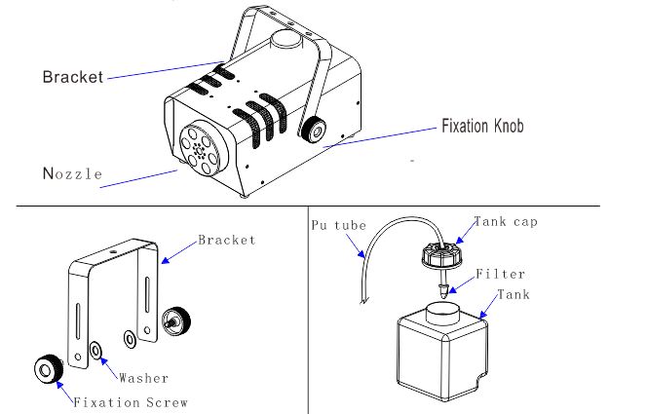
- X-T1220 Details

- Notes:
If you experience low output, pump noise or no output at all, unplug immediately. Check the fluid level, the external fuse, remote control connection and power from the wall. If all of the above appears to be O.K., plug the unit again. If fog does not come out after holding the remote button down for 30 seconds, check the hose attached to the tank to make sure there is fluid going through the hose. If you are unable to determine the cause of the problem, do not simply continue pushing the remote button, as this may damage the unit. Return the machine to your dealer or service center.
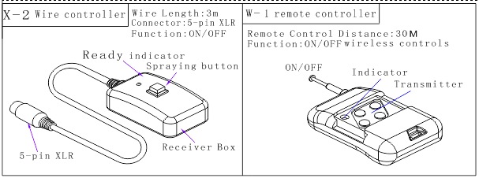
- Controllers
Controller X-2 Operation: Start by connecting the X-2 to the fog machine. Wait a few minutes When the LED on the remote glows green, it means the device is ready to fog. Please simply press the button to emit fog.
Wireless controller W-1 Operation: After warm up, when the device is ready to fog, Press “1", the fog machine will emit fog. When you release it, the machine will stop emitting. (Range up to 100 feet)
Caution: Before removing or replacing the remote control unit please shut down the power supply

PRODUCT WARRANTY INSTRUCTIONS
Complete warranty registration online at:
www.proxdirect.com/support/warranty
Registration and proof of purchase are required for warranty service. Please keep a copy of your purchase invoice.
DETAILS:
1. Warranty period: Parts & Labor for one year (The warranty starts from the date of purchase.)
2. If the products do not use the liquid of us or any other high-quality liquid, the warranty period will be shorten to three months. The cost which caused by replacing spare parts will be borne by users.
3. The warranty is void when:
A. The device has been improperly powered or operated incorrectly.
B. The device is physically damaged
C. The device is damaged my moisture or foreign objects in case.
D. The product has been modified by anyone other than ProX
4. Exclusions: Packaging materials, casing & bracket of the machine and batteries inside wireless remote controller. (Remove batteries for storage)
5. Warranty services is provided at no cost for labor or parts. Service outside of the warranty period or for damaged product will be charged at standard shop rates plus parts. (Shipping to and from service center not included)

Purchase Notes:
Date of Purchase: ___________________________________
Dealer Name: ______________________________________
Dealer Contact: _____________________________________
Dealer Phone:_______________________________________
Date of Registration:__________________________________
Find your dealer on our website to ask about more
Innovative products from…

901 Essex Street, Brooklyn, NY 11298
Voice 718.237.2299 – Fax: 718.237.2318
Email: info@proxdirect.com
(NO DIRECT SALES, DEALERS AND DISTRIBUTORS ONLY)
Register your products on ProXDirect.com

